|  |  |  |  |
| --- | --- | --- | --- |
| VIIT Pune (@viit_pune) | Twitter | Bansilal Ramnath Agarwal Charitable Trust's  Vishwakarma Institute of Information Technology  **Department of**  **Artificial Intelligence and Data Science** | | |
| Student Name: Sakshi Vijay Darandale | | | |
| Class: TY | Division: B | | Roll No: 371017 |
| Semester: 5th | | Academic Year: 2022-23 | |
| Subject Name & Code: Cloud Computing and Analytics | | | |
| Title of Assignment: Assignment no.1 Study of Cloud Computing & Architecture. | | | |
| Date of Performance: 01/12/2022 | | Date of Submission:02/12/2022 | |

Aim: Study of Cloud Computing & Architecture.

Problem Statement: Study of Cloud Computing & Architecture.

Background Information:

[Cloud Computing](https://www.geeksforgeeks.org/cloud-computing/) , which is one of the demanding technologies of the current time and which is giving a new shape to every organization by providing on demand virtualized services/resources. Starting from small to medium and medium to large, every organization use cloud computing services for storing information and accessing it from anywhere and anytime only with the help of internet. In this article, we will know more about the internal architecture of cloud computing.

Transparency, scalability, security, and intelligent monitoring are some of the most important constraints which every cloud infrastructure should experience. Current research on other important constraints is helping cloud computing system to come up with new features and strategies with a great capability of providing more advanced cloud solutions.

**Cloud Computing Architecture:**  
The cloud architecture is divided into 2 parts i.e.

1. Frontend
2. Backend

The below figure represents an internal architectural view of cloud computing.

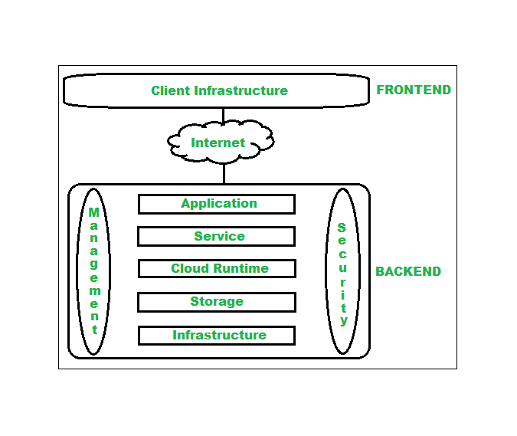

Architecture of cloud computing is the combination of both [SOA (Service Oriented Architecture)](https://www.geeksforgeeks.org/service-oriented-architecture/) and EDA (Event Driven Architecture). Client infrastructure, application, service, runtime cloud, storage, infrastructure, management, and security all these are the components of cloud computing architecture.

**1. Frontend:**  
Frontend of the cloud architecture refers to the client side of cloud computing system. Means it contains all the user interfaces and applications which are used by the client to access the cloud computing services/resources. For example, use of a web browser to access the cloud platform.

* **Client Infrastructure –** Client Infrastructure is a part of the frontend component. It contains the applications and user interfaces which are required to access the cloud platform.
* In other words, it provides a GUI(Graphical User Interface ) to interact with the cloud.

**2. Backend:**  
Backend refers to the cloud itself which is used by the service provider. It contains the resources as well as manages the resources and provides security mechanisms. Along with this, it includes huge storage, virtual applications, virtual machines, traffic control mechanisms, deployment models, etc.

1. **Application –**  
   Application in backend refers to a software or platform to which client accesses. Means it provides the service in backend as per the client requirement.
2. **Service –**  
   Service in backend refers to the major three types of cloud-based services like[**SaaS, PaaS and IaaS**](https://www.geeksforgeeks.org/cloud-based-services/). Also manages which type of service the user accesses.
3. **Runtime Cloud-**  
   Runtime cloud in backend provides the execution and Runtime platform/environment to the Virtual machine.
4. **Storage –**  
   Storage in backend provides flexible and scalable storage service and management of stored data.
5. **Infrastructure –**  
   Cloud Infrastructure in backend refers to the hardware and software components of cloud like it includes servers, storage, network devices, virtualization software etc.
6. **Management –**  
   Management in backend refers to management of backend components like application, service, runtime cloud, storage, infrastructure, and other security mechanisms etc.
7. **Security –**  
   Security in backend refers to implementation of different security mechanisms in the backend for secure cloud resources, systems, files, and infrastructure to end-users.
8. **Internet –**  
   Internet connection acts as the medium or a bridge between frontend and backend and establishes the interaction and communication between frontend and backend.

Types of cloud computing:

IT people talk about three different kinds of cloud computing, where different services are being provided for you. Note that there's a certain amount of vagueness about how these things are defined and some overlap between them.

* Infrastructure as a Service (IaaS) means you're buying access to raw computing hardware over the Net, such as servers or storage. Since you buy what you need and pay-as-you-go, this is often referred to as utility computing. Ordinary web hosting is a simple example of IaaS: you pay a monthly subscription or a per-megabyte/gigabyte fee to have a hosting company serve up files for your website from their servers.
* Software as a Service (SaaS) means you use a complete application running on someone else's system. Web-based email and Google Documents are perhaps the best-known examples. Zoho is another well-known SaaS provider offering a variety of office applications online.
* Platform as a Service (PaaS) means you develop applications using Web-based tools so they run on systems software and hardware provided by another company. So, for example, you might develop your own ecommerce website but have the whole thing, including the shopping cart, checkout, and payment mechanism running on a merchant's server. Force.com (from salesforce.com) and the Google App Engine are examples of PaaS.

**Benefits of Cloud Computing Architecture:**

* Makes overall cloud computing system simpler.
* Improves data processing requirements.
* Helps in providing high security.
* Makes it more modularized.
* Results in better disaster recovery.
* Gives good user accessibility.
* Reduces IT operating costs.

Conclusion: Cloud computing enables a convenient and on-demand network access to a wide range of resources. The different services and also the deployment models allow flexible service provider interaction with minimal human intervention. It saves costs but also can lead to risk issues and suspension of resources when in huge quantity.